Daniel McDonough

4/20/18

Bio Sim

Reflection

Current Progress:

* Swapped Topics from Protein Synthesis to SLE Testing
* Researched the autoimmune system pathway and it’s effects with lupus

Strategies Used:

* Looked for more visual explanations of the pathway system
* Thought of all major players in the simulation and if they should be agents or fields/attributes

Week Plans:

* Make skin cells patches
* Interactions between agents
* Create other agents
* Cell replication & death
* Recognition of antigens

New Abstract:

**Simulation in Biology Project Abstract**

**Group:** Cellular Biology

**Project name:** Systemic Lupus Erythematosus (SLE)

**Student name:** Daniel McDonough

**Project description:**

The immune system relies on several cells signaling to one another and passing information, but when distorted, this signaling can result in unintuitive processes. Systemic Lupus Erythematosus (SLE), the topic we will be focusing on, tricks antibodies into attacking healthy cells.

This simulation will look at what would happen across several positions in the SLE pathway and hope to add preventative measures to parts of the pathway in hope to model a theoretical solution to SLE. Possible by adding other proteins such as anifrolumab on the Tcell receptors inhibiting the production of antibodies.

**Agents and rules:**

*Healthy Cells:*

1) Patches in simulation representing healthy tissue

2) Is destroyed when attacked by corrupted autoantibodies

3) Have a chance of becoming Apoptotic

4) If apoptotic, has a chance of releasing nucleic antigens

5) Signals “Eat me” to Phagocyte while being apoptotic

*Antigens:*

1. Nucleic bits that signal “danger” to APC based on a chance of external factors
2. Can be discovered by APC, B-cells and antibodies
3. Can target dsDNA, or Smith

*Antigen-presenting cell (APC):*

1. Can find Antigens and pass on the info to helper Tcells

*Phagocyte:*

1. Find and eat Apoptotic cells
2. If antigens signal danger then

*Bcells:*

1. Agents that recognize nucleic antigens
2. Produces corrupt antibodies in response of the detection of the antigens
3. Can recognize the same info from Tcells

*Tcells:*

1. Transfers info between APC and Bcells
2. Able to be “vaccinated” to prevent the transfer of auto-antigens

*Antigen-Antibodies:*

1. Holds the dna of the antibody that caused it to spawn
2. Attacks all other cells with the same dna

**Model validation:**

1. The Antibodies are able to destroy healthy cells
2. Cells replicate
3. Cells die over time

**Hypotheses / Predictions:**

1. By inhibiting one common point of lupus it is possible to slow down or completely stop the inflammation/damage to healthy cells

**Evaluation (graphs, statistics):**

1) Amount of corrupted antibodies

**User Interaction (sliders, buttons):**

1. Predisposition button that effects the rate of apoptosis
2. Amount of UV light
3. Tcell vaccination button

**SLE Pathway**:

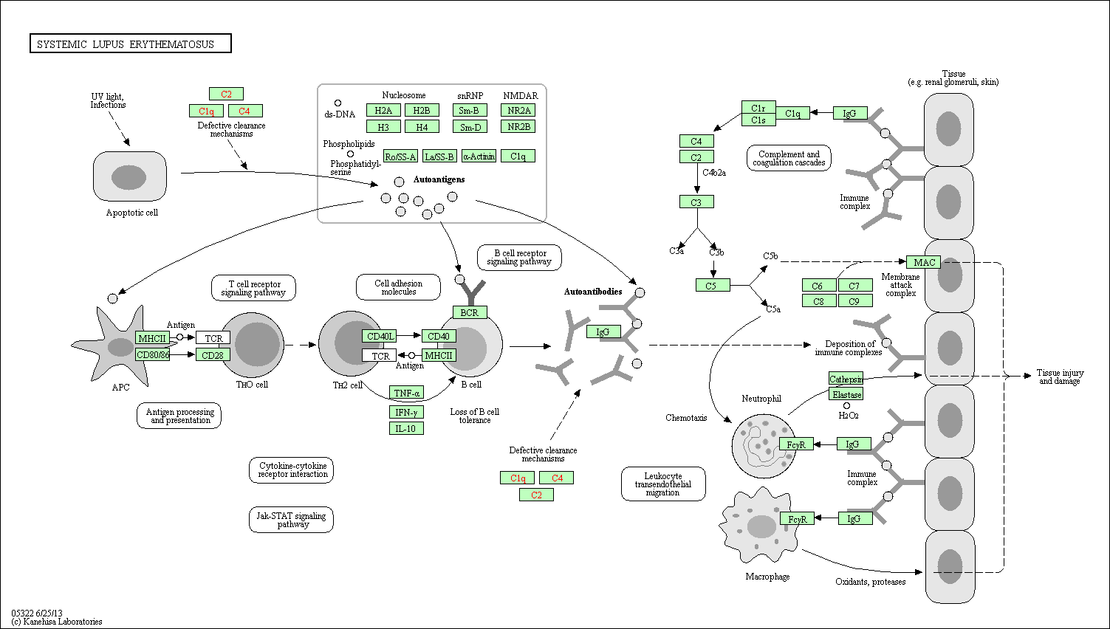

**References:**

* <https://en.wikipedia.org/wiki/Antigen-presenting_cell>
* <http://www.genome.jp/kegg-bin/show_pathway?org_name=hsa&mapno=05322&mapscale=&show_description=show>
* <https://en.wikipedia.org/wiki/Antigen-presenting_cell>
* <https://www.youtube.com/watch?v=23M35omW6H4>
* [https://www.astrazeneca.com/media-centre/press-releases/2015/AstraZeneca-presents-positive-new-data-on-anifrolumab-in-lupus-at-American-College-of-Rheumatology-Annual-Scientific-Meeting-10112015.html#](https://www.astrazeneca.com/media-centre/press-releases/2015/AstraZeneca-presents-positive-new-data-on-anifrolumab-in-lupus-at-American-College-of-Rheumatology-Annual-Scientific-Meeting-10112015.html)!